Health Care Project Architecture

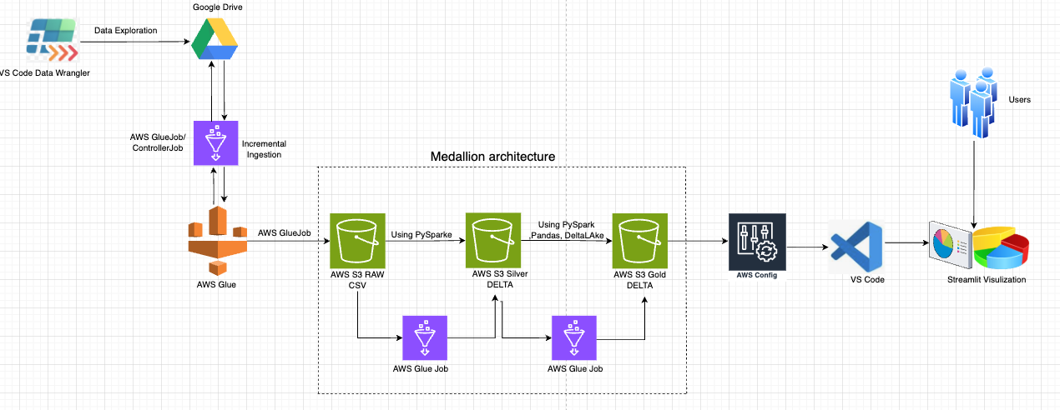

VS Code-Data Wrangler : Utilizing Data Wrangler extension in VS code for Data Exploration to understand and identify Missing values, duplicates , schema. Etc..

Google Drive: Source data in CSV format

AWS Glue Job/Controller Job : This job performs the daily scheduled check and pulls data into S3 Raw bucket using Google Drive API(boto3). It compares the modifiedTime of those files against the "Last Run Timestamp" (which you can store in AWS Systems Manager Parameter Store or as a Glue Workflow Property). It only downloads the files that are newer than that timestamp and streams them into S3 RAW bucket. This job automatically records the state (filenames and timestamps) of processed files in S3 and will only read newly uploaded files in subsequent runs.

Logic:
- Authentication: Use a Google Service Account and a JSON key file. For security, store this JSON in AWS Secrets Manager.
- API Logic: Use the google-api-python-client to list files. You can filter by folder ID and check the modifiedTime if you want to avoid downloading every file every time.
- S3 Upload: Use the boto3 library to stream the file directly from Google Drive to your S3 RAW path.

S3 RAW-CSV: Controller Glue Job loads required RAW CSV data files to S3 RAW bucket.

S3 SILVER- DELTA: Each individual curated/transformed table will be created in silver layer using different glue jobs using Glue’s native PySpark capabilities. These Glue jobs Implements the required transformations logic against RAW S3 bucket data and push it to S3 Silver. Silver layer typically contains validated, de-duplicated, and enriched data in the form of clean parquet files.

Advantage of Spark DataFrame : Performs complex joins, filters, and window functions—to leverage Spark's massive parallelism and in-memory speed.

S3 GOLD-DELTA: Another Glue job reads the Silver layer Parquet files data using spark and perform the Gold layer level aggregations (Based on required data metrics) and write it to Gold S3 in the Delta Format. Keeping gold layer in delta format gives the capabilities of ACID Transactions , Upsert Operations, Time Travel , Transaction Logs , Schema Enforcement etc..

AWS Config: In order to access the GOLD layer S3 from VS code I am going to install AWS CLI and run aws configure.

VS Code: In my VS Code terminal, I will configure (AWS Configure) required Access Key, Secret Key, and Region of my GOLD S3 bucket . Also import streamlit , pandas and deltalake libraries. The delta lake library will automatically handle S3 authentication using local aws configure settings.

Streamlit Visualization: In my vs code ‘app.py’ I will implement logic to load Delta table from Gold S3 and display different metrics data in the form of Line charts, pie charts , bar charts etc in the browser.
streamlit run app.py

Orchestration With AWS Glue WorkFlow :
Within an AWS Glue Workflow, this Orchestration is managed through a sequence of Triggers and Events.
- Scheduled Event:- This event triggers automatically based on scheduled time(eg: 2:00 AM Daily). It kicks off the Glue Controller Job(Ingestion Job).
- Ingestion Event:- Controller Job checks of Google Drive.
    - If new files are found and moved to S3 Raw, the job finishes with a "Success" status and sets a workflow property (e.g., data_ready = True).
    - If no files are found, the job still finishes, but you can configure it to stop the workflow right there to save costs.
- Conditional Event:- This Conditional trigger monitors the Above Controller job(Ingestion). As soon as it sees the Controller Job status change to SUCCEEDED, it evaluates its conditions.
It simultaneously triggers all Silver Layer Jobs. This is where parallel processing begins—each Silver job starts at the exact same moment.

- Completion Event:- This Conditional trigger monitors the Silver jobs. Once all designated Silver jobs report a SUCCEEDED status, this trigger fires and starts the Gold Layer Job to perform the final Delta format aggregations.

- Monitoring Event:- IF Needed I can have this trigger to monitor and capture Failure Events. This trigger can send an Amazon SNS (Simple Notification Service) alert to an email or Slack, letting us know the workflow failure before your Streamlit app tries to display stale data.

